***Binary Search (Recursive)***

**Problem:**Given a sorted array **arr[]** of **n** elements, write a function to search a given element **x** in**arr[]**and return the index of x in the array.

                 Consider array is 0 base index.

**Examples:**

***Input:****arr[] = {10, 20, 30, 50, 60, 80, 110, 130, 140, 170}, x = 110*  
***Output:****6*  
***Explanation:****Element x is present at index 6.*

***Input:****arr[] = {10, 20, 30, 40, 60, 110, 120, 130, 170}, x = 175*  
***Output:****-1*  
***Explanation:****Element x is not present in arr[].*

**Binary Search Approach:**

***Binary Search****is a*[*searching algorithm*](https://www.geeksforgeeks.org/searching-algorithms/)*used in a sorted array by****repeatedly dividing the search interval in half****. The idea of binary search is to use the information that the array is sorted and reduce the time complexity to O(Log n).*

**Binary Search Algorithm:** The basic steps to perform Binary Search are:

* Begin with the mid element of the whole array as a search key.
* If the value of the search key is equal to the item then return an index of the search key.
* Or if the value of the search key is less than the item in the middle of the interval, narrow the interval to the lower half.
* Otherwise, narrow it to the upper half.
* Repeatedly check from the second point until the value is found or the interval is empty.

high = mid - 1

Recursive Method (The recursive method follows the divide and conquer approach)

binarySearch(arr, x, low, high)

if low > high

return False

else

mid = (low + high) / 2

if x == arr[mid]

return mid

else if x > arr[mid] // x is on the right side

return binarySearch(arr, x, mid + 1, high)

else // x is on the left side

return binarySearch(arr, x, low, mid - 1)

**Illustration of Binary Search Algorithm:**

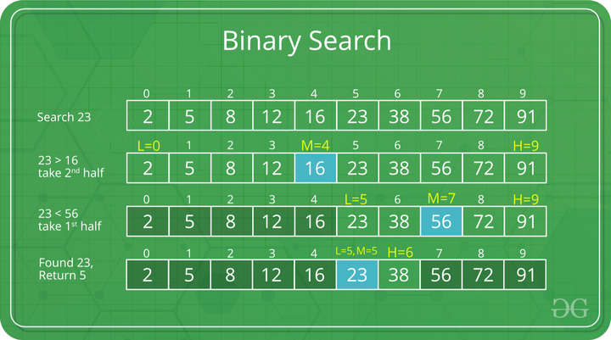*Example of Binary Search Algorithm*

**Step-by-step Binary Search Algorithm:** We basically ignore half of the elements just after one comparison.

1. Compare x with the middle element.
2. If x matches with the middle element, we return the mid index.
3. Else If x is greater than the mid element, then x can only lie in the right half subarray after the mid element. So we recur for the right half.
4. Else (x is smaller) recur for the left half.

**Recursive implementation of Binary Search**:

Java

// Java implementation of recursive Binary Search

class BinarySearch {

// Returns index of x if it is present in arr[l..

// r], else return -1

int binarySearch(int arr[], int l, int r, int x)

{

if (r >= l) {

int mid = l + (r - l) / 2;

// If the element is present at the

// middle itself

if (arr[mid] == x)

return mid;

// If element is smaller than mid, then

// it can only be present in left subarray

if (arr[mid] > x)

return binarySearch(arr, l, mid - 1, x);

// Else the element can only be present

// in right subarray

return binarySearch(arr, mid + 1, r, x);

}

// We reach here when element is not present

// in array

return -1;

}

// Driver method to test above

public static void main(String args[])

{

BinarySearch ob = new BinarySearch();

int arr[] = { 2, 3, 4, 10, 40 };

int n = arr.length;

int x = 10;

int result = ob.binarySearch(arr, 0, n - 1, x);

if (result == -1)

System.out.println("Element not present");

else

System.out.println("Element found at index "

+ result);

}

}

**Output**

Element is present at index 3

**Time Complexity:** O(log n)  
**Auxiliary Space:** O(log n)